Birth of the Renaissance
Birth of the Renaissance |  |  | Data-based question

Name︰_______________ （ ） Class︰__________

Historical skill | Inducing and inferring
Related Textbook Content | 2A pp.11-15

Study the sources below and answer the following questions.

Source A Extract from an article about the Renaissance
Renaissance literally means ‘rebirth’, and it refers to the rebirth of two things: The first is the the rebirth of man, the greater importance of human presence and human thoughts on earth. The second was the rebirth of ancient Greek and Roman cultures. It was the Florentines who first embarked on a journey to increase their knowledge of science, mathematics, literature and the arts.

Source B School of Athens, a painting from the Renaissance period. The people in the painting were ancient Greek and Roman thinkers.
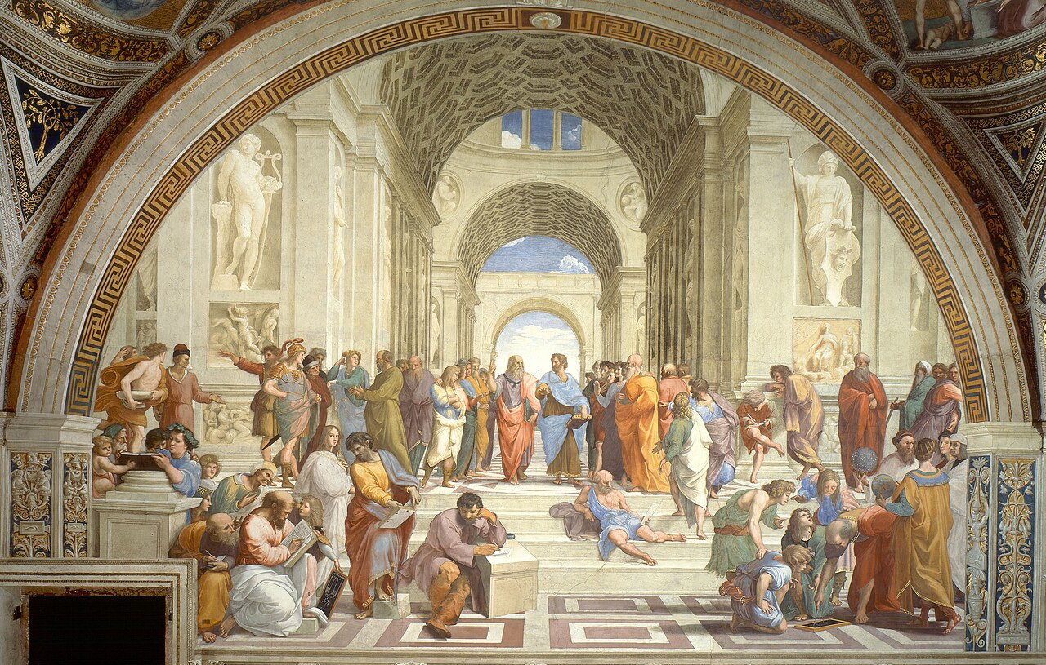

1. According to Source A, which two characteristics of the Renaissance below is correct? ( add ) Understand source
Promoting religious ideas related to heaven
Stressing on the worldview with humans as the centre
Reviving classical civilisation
Following historical artifacts in Florence

2. According to Source A, which city was the birthplace of the Renaissance?
Understand source
According to Source A, ______________ was the birthplace of the Renaissance.

3. How did the painting of Source B reflect features of the Renaissance as mentioned in Q(1)?
Observe, analyse source
Tips: Pay attention to the identities and actions of the characters in the painting

The theme of the painting revolves around ______________________________ , and it depicts them ________________________ . This reflected that the Renaissance treated values of [ heaven / humans ] as important. Also, characters of the painting came from _________________________, which shows that cultures from these two periods were famous during the Renaissance.

Answers

1.
Promoting religious ideas related to heaven
Stressing on the worldview with humans as the centre
Reviving classical civilisation
Following historical artifacts in Florence

2. According to Source A, ____Florence___ was the birthplace of the Renaissance.

3. The theme of the painting revolves around ________ ancient Greek and ancient Roman thinkers___ , and it depicts them _____conducting academic discussion_____ . This reflected that the Renaissance treated values of [ heaven / humans ] as important. Also, characters of the painting came from ______ ancient Greece and ancient Rome______, which shows that cultures from these two periods were famous during the Renaissance.

